# ****30**** Best Kitchen Cabinet Designs of 2022 In Dubai

The kitchen is a popular space in most homes, and it's no wonder why. It's the place where families get together to cook great food for dinner or breakfast, and it's the heart of home life. But over time, kitchens have evolved; they are no longer just utilitarian spaces with basic appliances and traditional cabinets.

Modern cabinet design ideas can make your kitchen look more stylish while also serving its original purpose: to be an efficient workspace that serves as storage for all of your family-friendly cooking needs. The following Modern Kitchen cabinet design ideas will show you how beautiful cabinets can be on top of being functional.

**1- Chippendale Cabinets**

These cabinets are named after the Chippendale furniture style, which is characterized by its intricate carvings and curves. Chippendale cabinets usually have a dark wood finish with lighter highlights, giving them a rich look that will elevate the overall design of your kitchen.

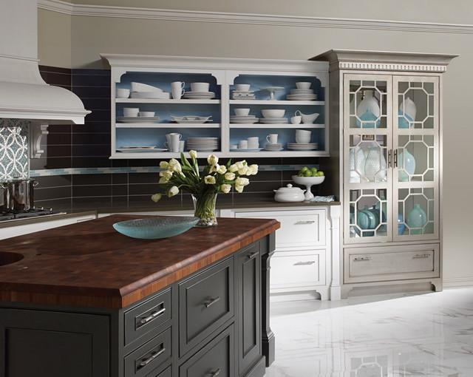

**2- Cabinets with Metal Strapping**

**Metal strapping is a simple detail that can instantly modernize your cabinets. Metal strapping comes in different finishes, giving you plenty of options to create a unique look that fits the rest of your kitchen's design scheme.**

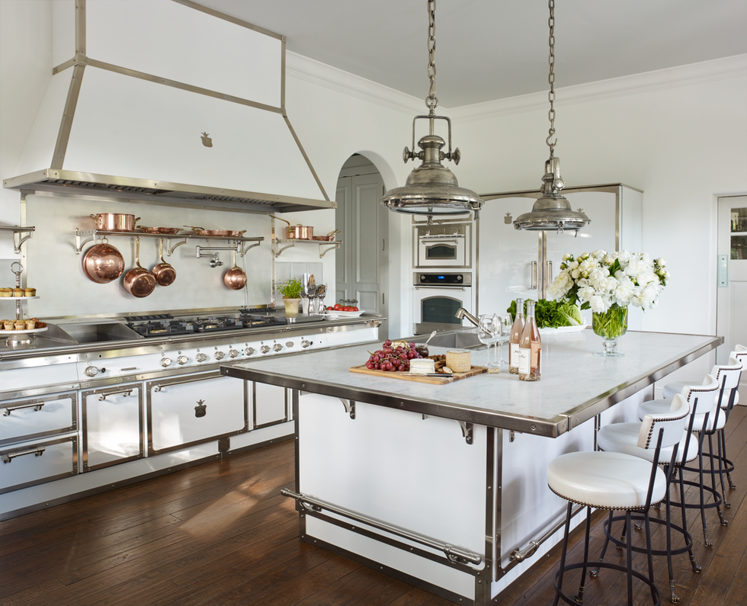

**3- Frosted Glass Cabinets**

Frosted glass cabinets may not be as see-through as regular old glass, but their semi-opaque finish still lets you see what's inside without having to pull out every single item. The best part is that frosted glass cabinets can come in a variety of colors, allowing you to customize your kitchen with unique accents.

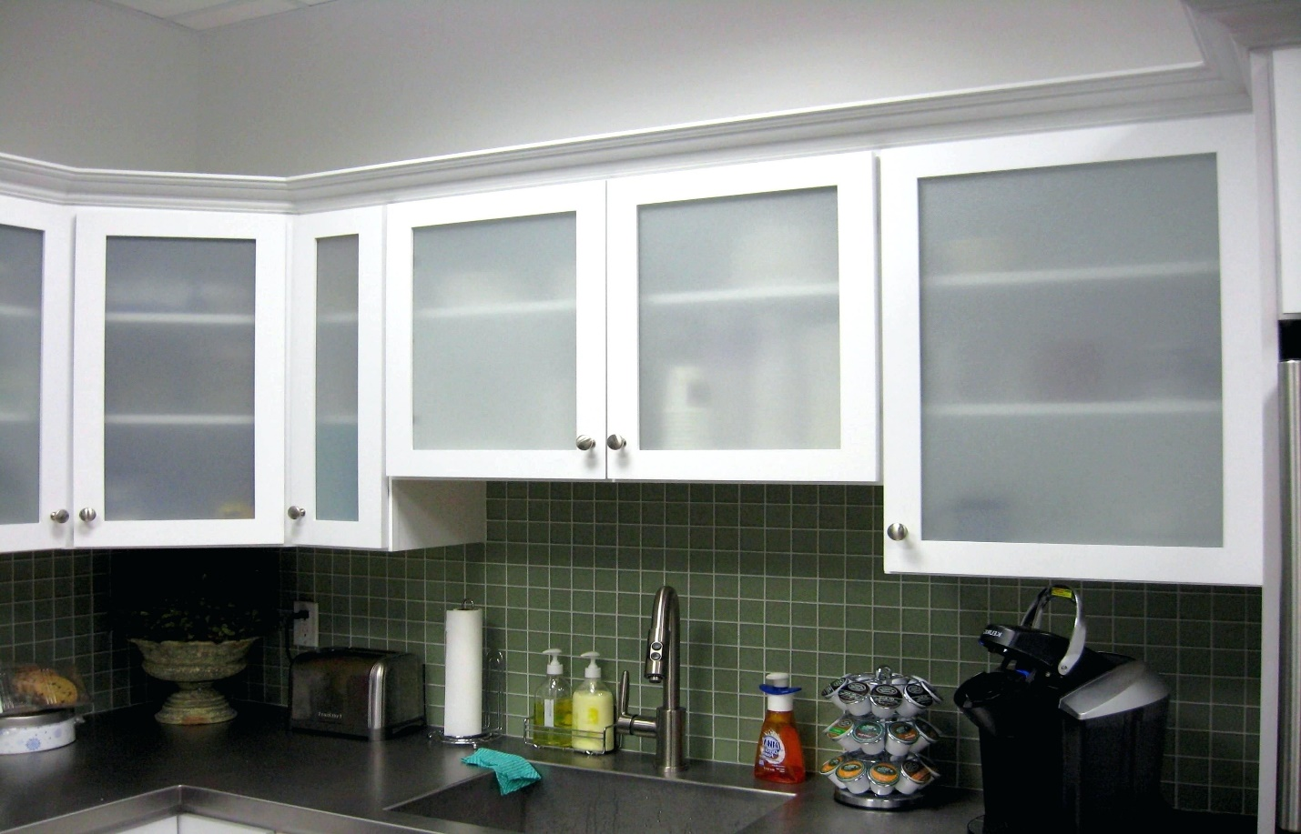

**4- Cabinets with a Tinted Finish**

When you paint your cabinets, don't settle for one solid color. Mix different tints to create an ombré like effect like the ones below. Different tints will allow you to experiment with various shades and hues of your favorite color. To help you decide which tints work for you, just print out a picture of the color palette and place it on your cabinets.

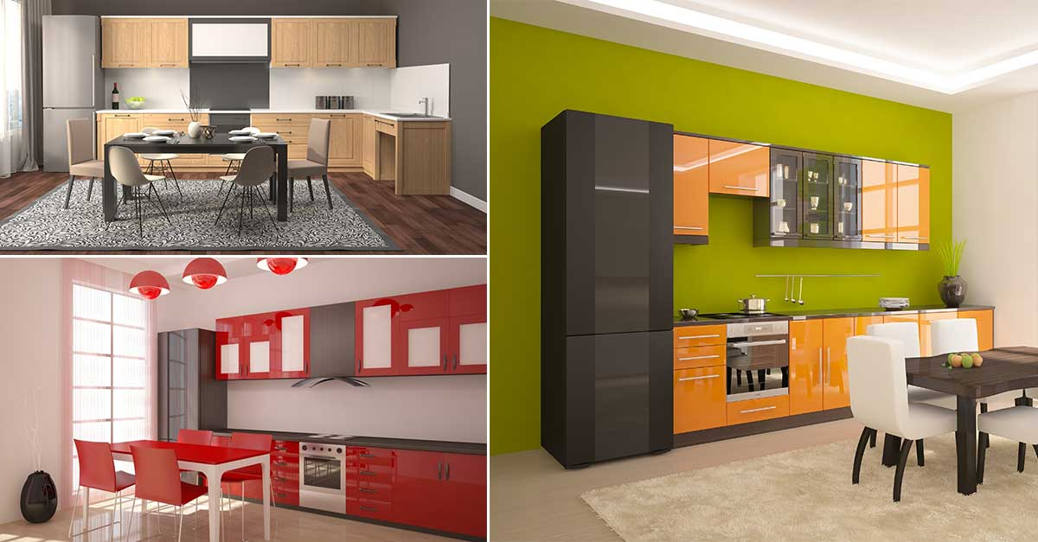

**5- Wooden Panels Cabinets**

If paint colors are too basic for your tastes, try adding wooden panels with unique details to your cabinets. Framed elements such as tiles or stone and latticework and veneer allow you to add a stylish flair to your cabinets.

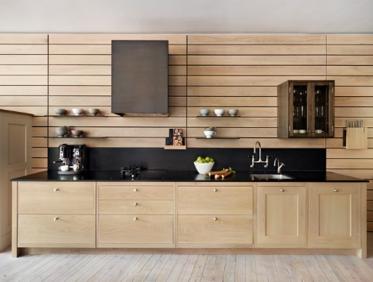

**6- Unfinished Cabinets**

Unfinished cabinets in brown natural wood shades are the natural look of the epitome. Or, if you prefer a more contemporary look, you could opt for unfinished cabinets with a gray finish.

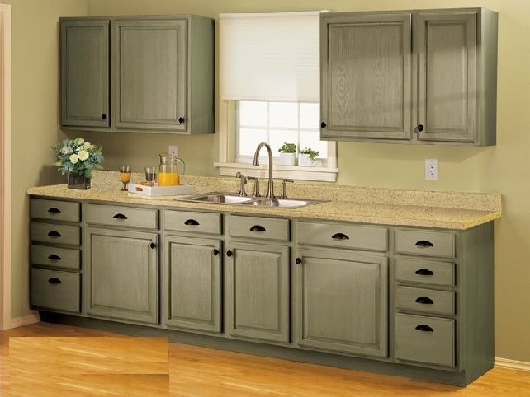

**7- Glass Doors on Your Cabinet**

Glass doors on your cabinets allow you to showcase all of your dishes while also giving a glimpse into the cabinets themselves. If you have fancy utensils or other interesting pieces, this cabinet design idea may be the best one for you.

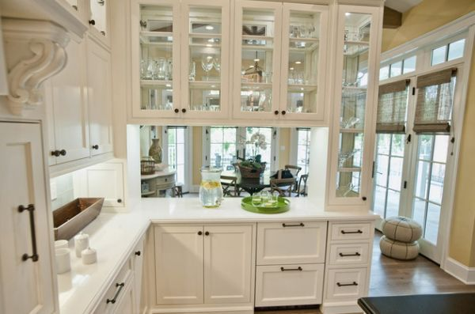

**8- Brushed Aluminum Cabinets**

Brushed aluminum cabinets give your kitchen a sleek and ultra-modern look. The aluminum will also keep your cabinets lightweight while maintaining their durability.

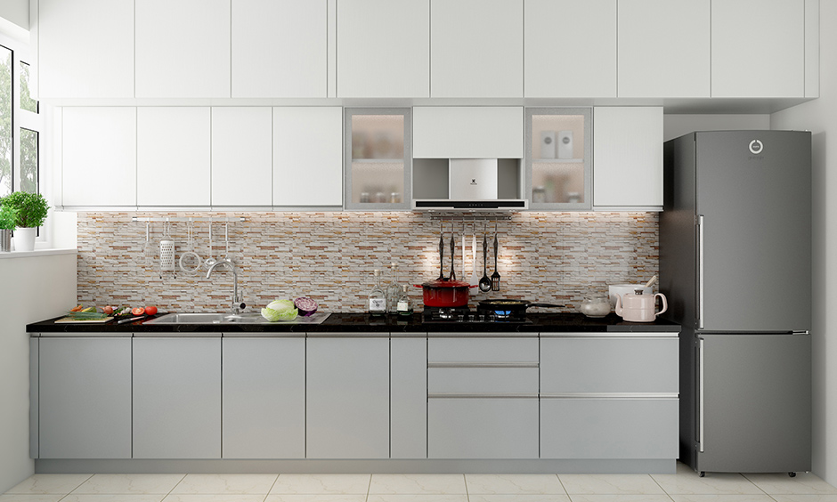

**9- The "Barn" Cabinet Doors**

The term barn door seems to be undefined in the world of cabinet design, but it typically refers to cabinets with wide arched openings. Barn style doors are perfect for houses located in warmer climates, where airflow is necessary for keeping your kitchen from getting too stuffy.

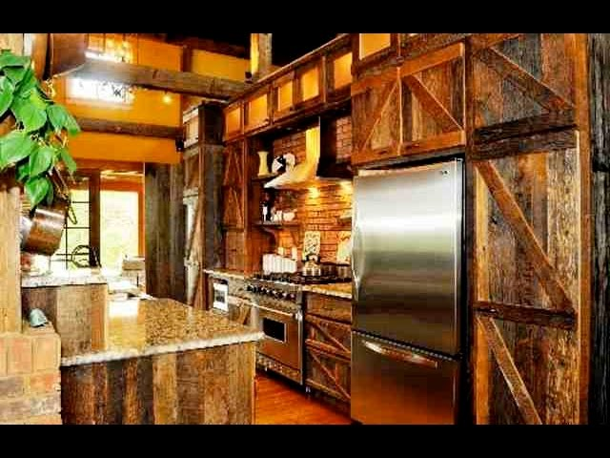

**10- The "Tilt-Out" Cabinet Door**

One of the modern cabinet design ideas that truly revolutionized kitchen space was creating cabinets with tilt-out doors, which made unloading and loading your cabinets so much easier. Tilt outdoors can be incorporated into any style of cabinetry to create a space-saving design element.

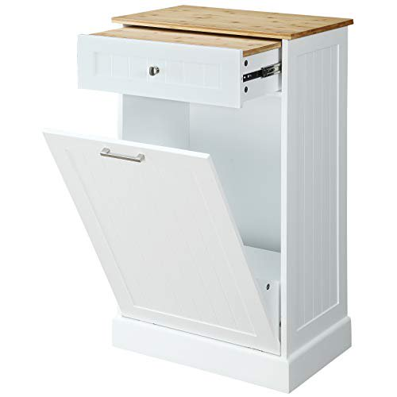

**11- Cylindrical Cabinets**

Cabinets with cylindrical curves don't have to be brassy or over-the-top. An elegantly curved cabinet door will simply give your kitchen a more cohesive feel.

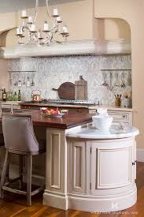

**12- The Open Shelving Cabinet**

The open shelving cabinet is one of the simplest forms of modern kitchen design. You can easily DIY this look by using open cubes, or you can opt to buy prefab cabinets.

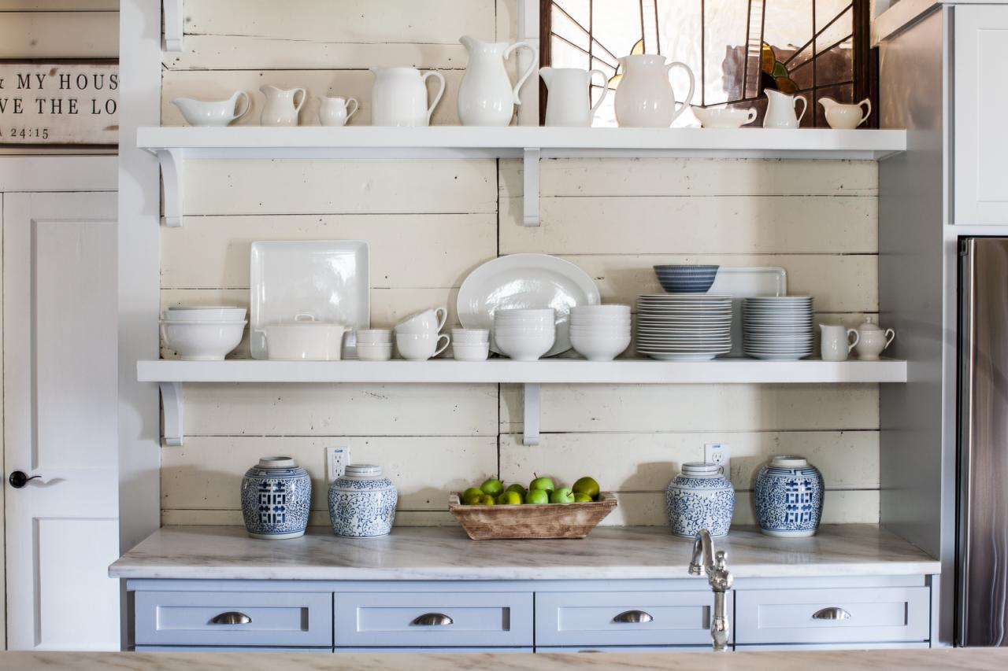

**13- Wall Mounted Cabinets**

Wall-mounted cabinets are modern cabinet design ideas that focus on utilizing space efficiently. This is an especially good idea for small homes where every inch of space counts.

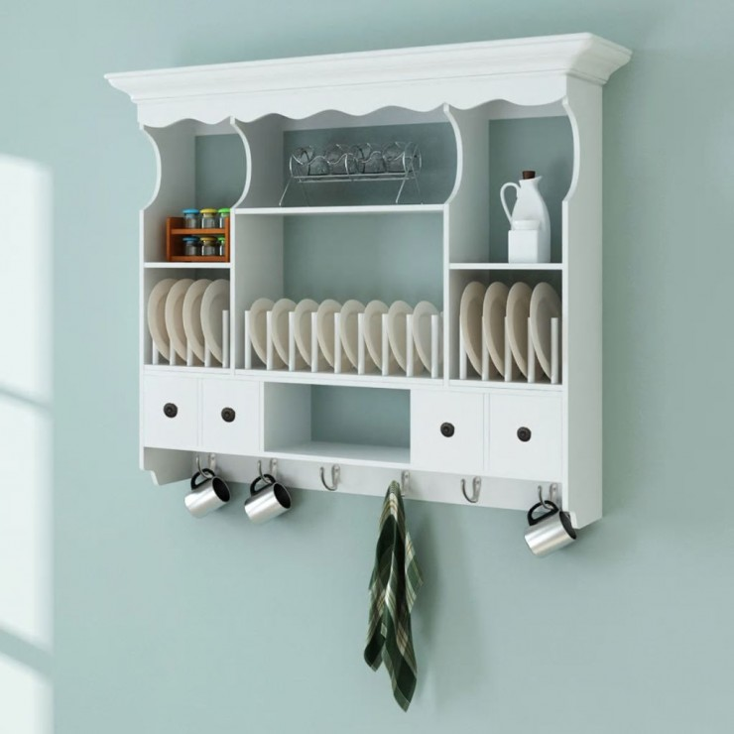

**14- Minute Handles**

Cabinet knobs don't have to be boring. Minute cabinet knobs are a very modern twist that both update the look of your cabinets while also adding an extra design element to any style or color of cabinetry.

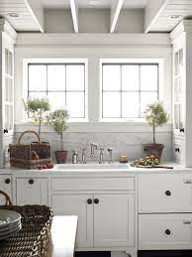

**15. Black Kitchen Cabinet Design**

Black cabinets are a high-tech way of getting that perfect look. This will allow you to stay on-trend while also keeping your kitchen looking sleek and contemporary.

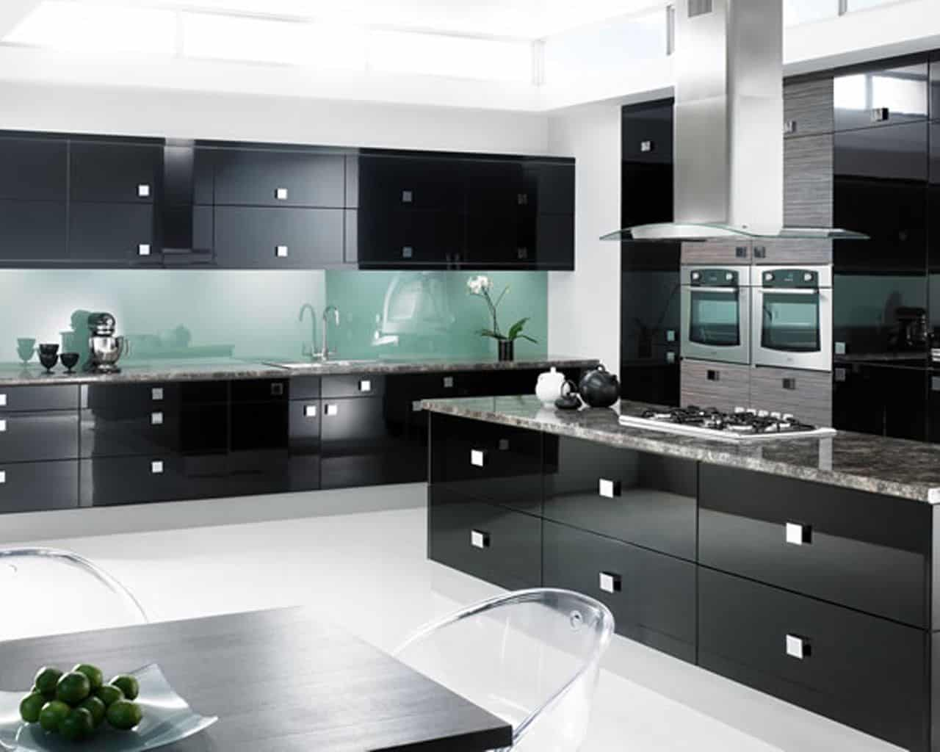

**16- The Glossy White Kitchen Cabinet**

One of the most popular colors for cabinets in recent years has been white. Cabinets with glossy finishes allow you to create a clean and modern look without having to spend a lot of money on custom cabinetry.

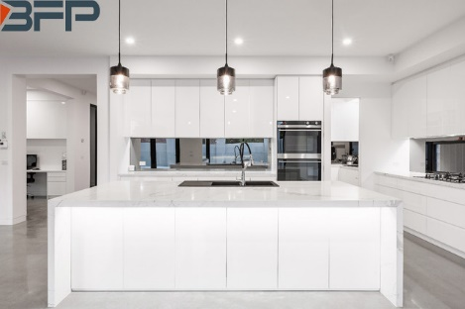

**17- Recessed Cabinet Doors**

Recessed cabinet doors are another way that you can save space in your kitchen without sacrificing all of your dishes. The sleek design also contributes to the contemporary feel of your kitchen cabinet renovation project.

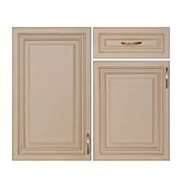

**18- Mirror Insert Cabinet Doors**

This is another simple and elegant way of updating your kitchen for a modern feel. Glass and mirror inserts can also give you a more spacious look, regardless of how limited your space may be.

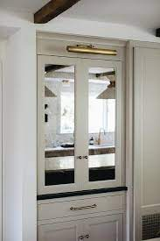

**19- The Curved Tambour Cabinet Door**

The curved tambour cabinet door is another modern idea that will create an interesting focal point for your kitchen. Plus, it allows you to utilize that extra space that can sometimes accumulate behind closed cabinet doors.

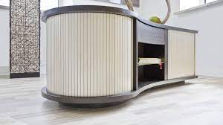

**20- The "Floating" Cabinet**

The floating cabinet may not be for everyone's taste, but they are certainly an interesting piece of modern design. You can use them as a room divider, or you can utilize the space in a decorative manner. Either way, they create a stylish focal point for your kitchen that will get people talking.

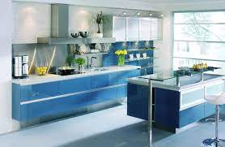

**21- The Shaker Style Cabinets**

The shaker style of cabinetry has been around for many years and is one of the most popular styles of cabinets on the market. Its simple, timeless design continues to be a trend for all homes, regardless of the overall style.

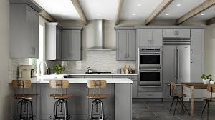

**22- The Pantry Cabinet**

The pantry cabinet may not be a glamorous piece of furniture, but they certainly play an important role in your home. By giving yourself options and utilizing all available space, you will create a functional and smart kitchen design plan.

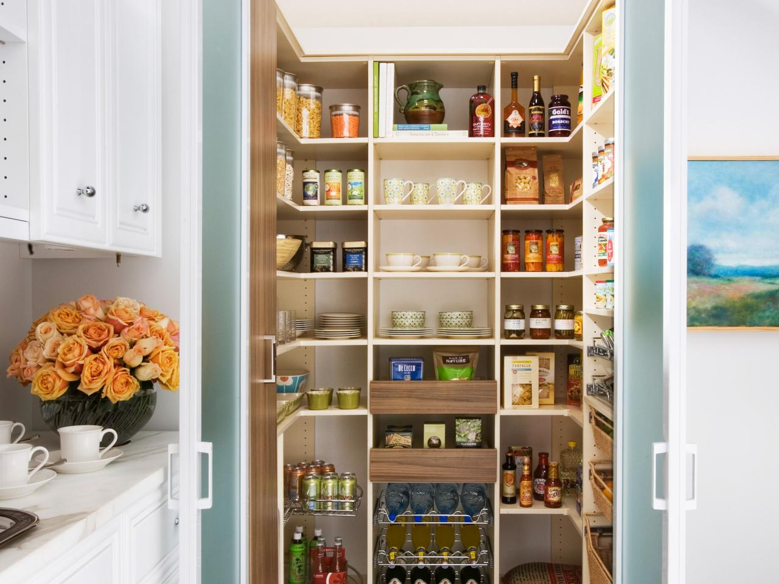

**23- The Corner Cabinet**

The corner cabinet is often overlooked when it comes to interior design ideas. However, this piece of modernism can be the perfect way to utilize a small space. Whether you're trying to save space or simply seeking out an interesting focal point, this cabinet design idea is ideal for any home.

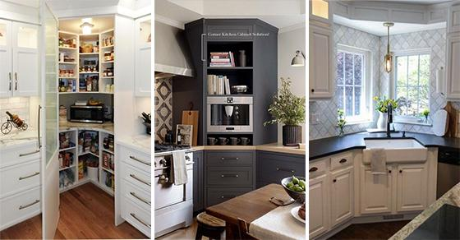

**24- The Double Door Wall Cabinet**

Double door wall cabinets allow you to create the illusion of more cabinet space without actually having to expand your real estate. This can be especially useful if you're seeking to add a bold focal point to your kitchen without actually having to add more cabinetry.

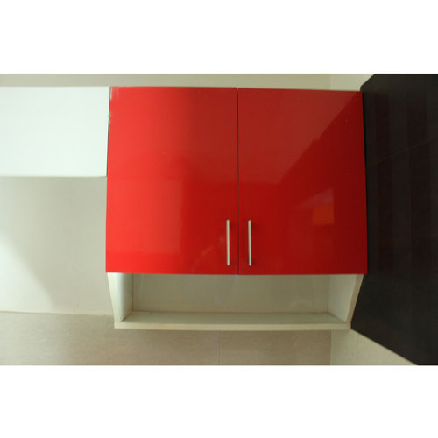

**25- The "Wine Me" Cabinet**

The wine me cabinet is an interesting concept that allows human beings the perfect amount of space for their personal liquor collection. If you have had issues with finding space for your wine glasses, this may be the perfect solution.

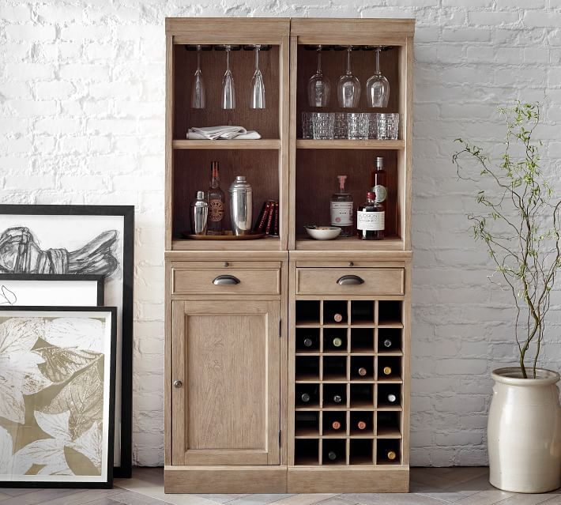

**26- White Cabinets with Brass or Copper Hardware**

One of the advantages of having white cabinets is that they will match almost any type of hardware. If you're trying to achieve a sleek modern look, this is yet another way to do so without sacrificing the overall design.

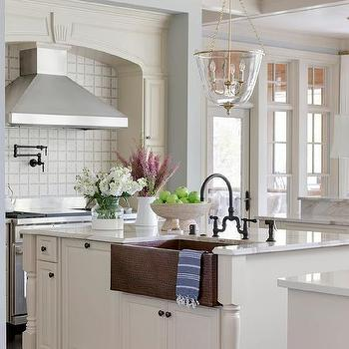

**27. Brown Wooden Cabinets**

One of the benefits of wooden cabinets is that they are easy to receive. That's why you're often able to find them in most home improvement stores or kitchen design centers. However, this doesn't mean you should stick with basic colors every time. Brown wooden cabinets create a more rustic and organic feel, which can be perfect for those who want a classy kitchen design.

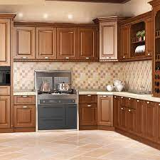

**28- The Heavy Metal Cabinets**

Heavy metal cabinets are perfect for those who want an industrial feel with their modern kitchen design idea. This option is great for making everything feel more streamlined while also creating that perfect focal point that everyone at the party will talk about.

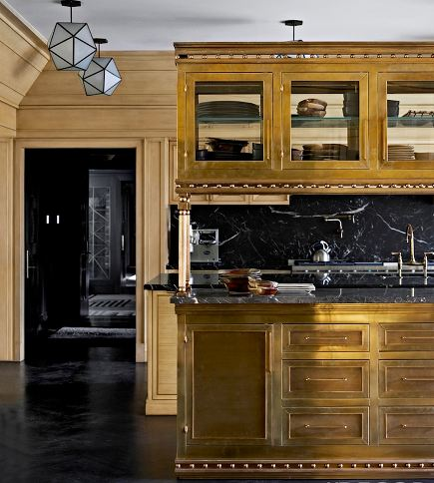

**29. Drawer Cabinets**

Drawer cabinets are a simple yet smart design that allows you to store your food, pots, pans, dishes, silverware, etc., easily. The options are endless when it comes to the amount of storage space available with these cabinets.

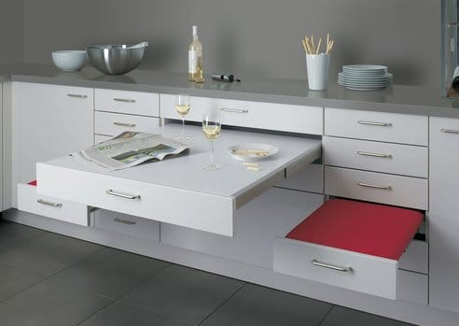

**30- Metal Grate Cabinets**

**Metal grate cabinets provide a vintage style to your kitchen and a luxurious and elegant look. The metal grate panels look like they came straight out of a 19th-century factory, lending an ancient feel to the room while also providing necessary storage space. These cabinets are also durable and can improve the look of any kitchen.**

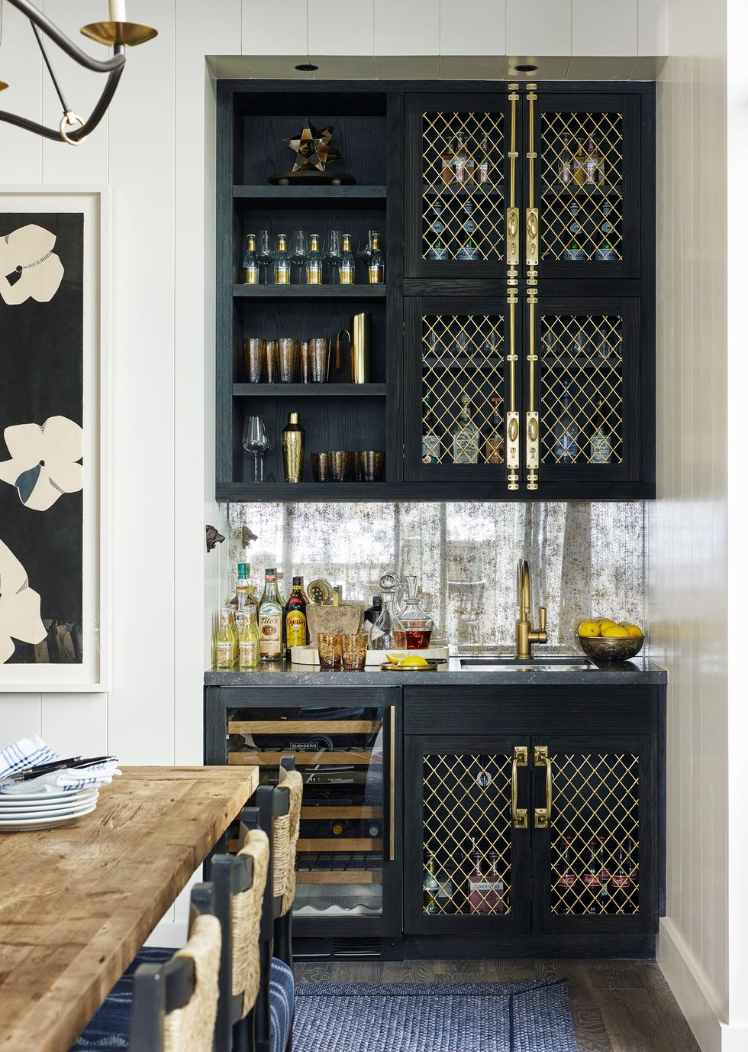

# Conclusion

# We hope you've found our list of the 30 best kitchen cabinet designs for 2022 helpful. If you're looking to remodel your own kitchen and want some inspiration, we invite you to visit our [Kitchen showroom in Dubai](https://www.almeera.me/), where we have a full range of cabinets on display that will help spark your creativity.

# From quartz countertops and backsplash tiles to wall colors and appliances, we can help turn your dream into reality! Let us know what design interests you most from this list or if there's anything else specific about kitchens that interests you - so we can be sure those questions are answered by one of our experts at The Almeera Kitchen Store.